ATLAS FITNESS
ATLAS FITNESS is a gym that wants a system to help in management of its trainers, clients and one that gives the owner control and a good overview of the day-to-day running of the gym while providing the trainers with means to communicate reliably with their clients to better guide them on their fitness journeys. The system also aims to provide member with seamless user experience, flexibility and keep the client fully informed on what is happening during their fitness journey.
  - OBJECTIVES OF THE MANAGEMENT SYSTEM
The system needs to achieve the following to prove useful:
For the owner
The owner’s job is to manage the gym’s daily operations so the system is aimed at doing the following for the owner:
- Allow the owner to keep track of key metrics of the gym’s operations such as memberships, workout programs and trainers
- Enable adding, editing and removal of trainer profile
- Enable tracking of user profiles and memberships
- Allow the owner to add, update and remove workout programs
- Allow the owner to assign or reassign trainers to various programs

For the trainer
The trainer’s job is to guide gym goers on their fitness journey by providing guidance and appropriate feedback so the system helps by:
- Enabling the trainers to track their clients and view their profile along with their goals
- Allows the trainers to give and update routines for their clients based on their goals
- Allows them give feedback on weak areas along with meal suggestions for their clients’ goals
- Allows the trainer to record their clients progress

For the users
The user is to be able to access gym services and track their fitness on the app on the Atlas Fitness Program they should hence be able to do the following:
- Register and login safely into the system
- Manage their personal profile
- Select and or change their personal trainer based on trainer availability
- Access various workout programs according to their goals and preferences
- View membership status and details
- Track personal progress
- View attendance history
- View payments history
Possible tables and fields
- Users-User ID, first Name, last name, Email, Phone number, password, role
- Memberships-ID, user ID, payment ID ,start date, end date, price, duration
- Member-ID, user ID, Height, weight, gender, DOB, goal, membership expiry date
- Trainer table-ID, user ID, Specialization, Bio, Years of experience
- Trainer assignments- ID, Trainer ID, Member ID, Assignment date
- Training program-ID, Member ID, Trainer ID, Program title, Program description
- Attendance-ID, user ID, check in, check out
- Progress-ID, member ID, date, Chest , arms, body fat percentage, thighs , waist
- Payments- ID, means, amount, time, User ID

User table
Field name | Description | Data type | Constraint
User ID | Primary key | Serial | Primary key
First name | First name | Varchar(255) | Not null
Last name | Last name | Varchar(255) | Not null
Email | User email | Varchar(255) | Not null unique
Phone number | User contact | Varchar(255) | Not null unique
Password(hashed) | User password | Varchar(255) | Not null
Role | Admin or trainer or regular user | Varchar(255) | Not null

Memberships
Field name | Description | Data type | Constraint
Membership ID | Primary key | Serial | Primary key
User ID | Foreign key | Int | Foreign key
Payment ID | Foreign Key | Int | Foreign Key
Start date |  | Timestamp | Default current_timestamp
End date |  | Timestamp | Default current_timestamp
Price |  | Money | Default 10,000

Member
Field Name | Description | Data type | Constraint
Member ID | Primary Key | serial | Primary key
User ID | Foreign key | Int | Foreign key
Height |  | Int | Not null
Weight |  | Int | Not null
Gender |  | Varchar(120) | Not null
DOB |  | Date | Not null
Goal |  | Varchar(300) | Not null
Expiry date |  | Date | Not null

Trainers
Field name | Description | Data type | Constraint
Trainer ID | Primary Key | serial | Primary key
User ID | Foreign key | Int | Foreign key
Specialization |  | Varchar(255) | Not null
Bio |  | text | Not null
Years of Experience |  | Int | Not null

Trainer assignment
Field name | Description | Data type | Constraint
Assignment ID | Primary Key | Serial | Primary key
Trainer ID | Foreign key | Int | Foreign key
Member ID | Foreign key | Int | Foreign key
Assignment date |  | date | Not null

Training Program
Field name | Description | Data type | Constraint
Program ID | Primary key | Serial | Primary key
Member ID | Foreign key | Int | Foreign key
Trainer ID | Foreign key | Int | Foreign key
Program Title |  | Varchar(255) | Not null
Program description |  | Text | Not null

Attendance
Field Name | Description | Data type | Constraint
Attendance ID | Primary key | Serial | Primary key
Member ID | Foreign key | Int | Foreign key
Check in |  | Date | Not null
Check out |  | Date | Not null

Progress
Field name | Description | Data type | Constraint
Progress ID | Primary key | Serial | Primary key
Member ID | Foreign key | Int | Foreign key
Date |  | Date | Foreign key
Chest |  | Int | Not null
Arms |  | Int | Not null
Body fat percentage |  | Int | Not null
Thighs |  | Int | Not null
waist |  | Int | Not null

Payments
Field name | Description | Data type | Constraint
Payment ID | Primary key | Serial | Primary key
User ID | Foreign key | Int | Foreign key
Means |  | Varchar(255) | Not null
Amount |  | money | Not null
Created at |  | timestamp | Default current_timestamp

Entity Relationship Diagram

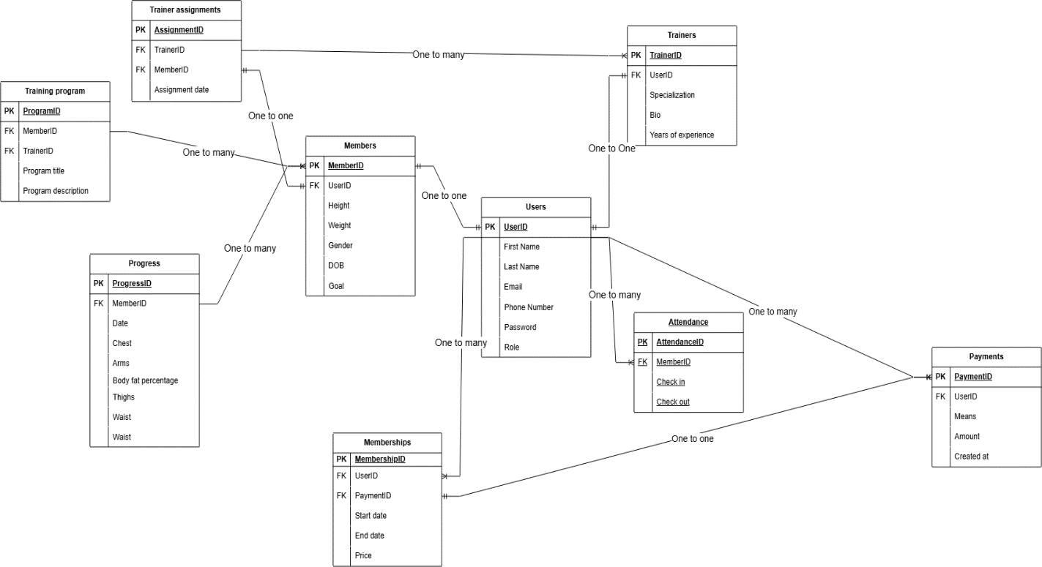

General Program flow
